Anthony D’Alessandro

Probability and Applied Statistics – StatsLibrary Demo

**Calculation Methods**

Mean, Median, and Mode

* Given list of integers with no mode: (1, 5, 3, 4, 7, 8)

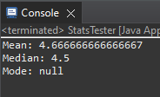

Output:

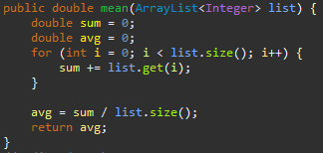

Mean Method:

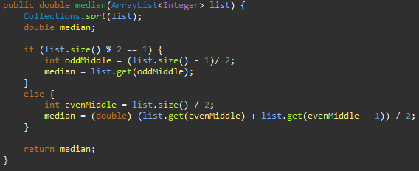

Median Method:

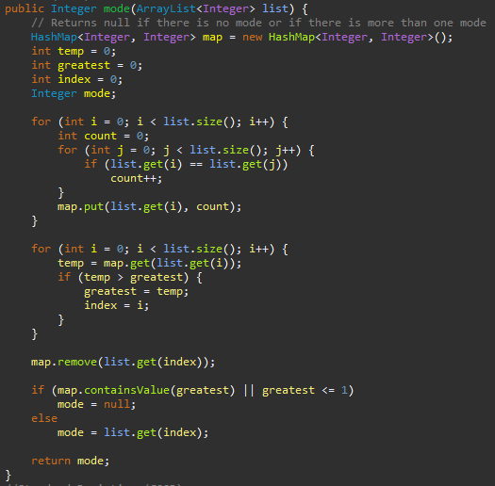

Mode Method:

Mode

* Given list of integers with a mode: (1, 1, 5, 3, 4, 7, 8)

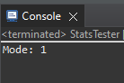

Output:

Mode

* Given list of integers with more than one mode: (1, 3, 3, 5, 5)

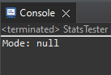

Output:

Standard Deviation

* Given list of integers: (1, 5, 3, 4, 7, 8)

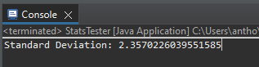

Output:

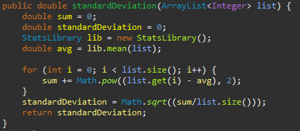

Standard Deviation Method:

**Set Operations**

Complement

* Given list of integers: (1, 5, 3, 4, 7, 8) & Universal Set of integers [1-10] : (1, 2, 3, 4, 5, 6, 7, 8, 9, 10)

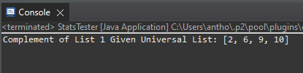

Output:

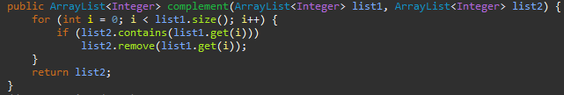Complement Method:

Intersection

* Given List 1: (1, 5, 3, 4, 7, 8) & List 2: (1, 3, 5)

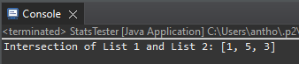

Output:

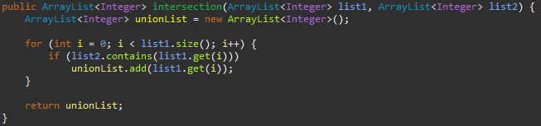Intersection Method:

Union

* Given List 1: (1, 5, 3, 4, 7, 8) & List 2: (9, 10, 11)

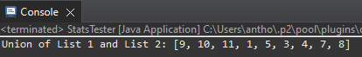

Output:

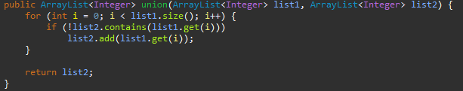Union Method:

**Factorial, Permutations, and Combinations**

Factorial

* Given n = 12

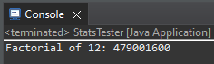

Output:

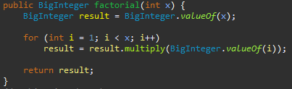

Factorial Method:

Permutation

* Given n = 7 & r = 2

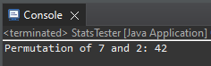

Output:

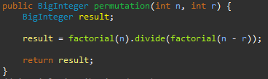

Permutation Method:

Combination

* Given n = 7 & r = 2

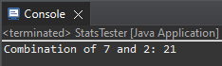

Output:

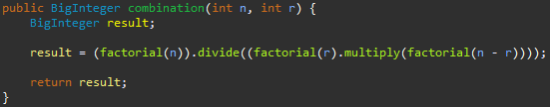Combination Method:

**Binomial and Geometric Distributions**

Binomial Distribution

* Given p = 0.80, q = 0.20, n = 10, and y = 7

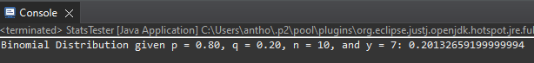

Output:

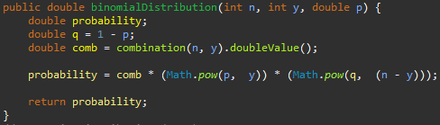Binomial Distribution Method:

Geometric Distribution

* Given p = 0.04, q = 0.96, and n = 6

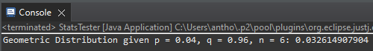

Output:

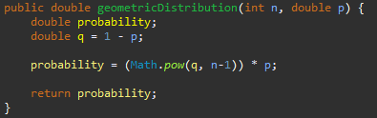

Geometric Distribution Method:

**Birthday Problem Program**

Birthday Problem Using (MM/DD Format)

* Given 100 runs & user input of 25 people

Output:

Birthday Problem Methods: 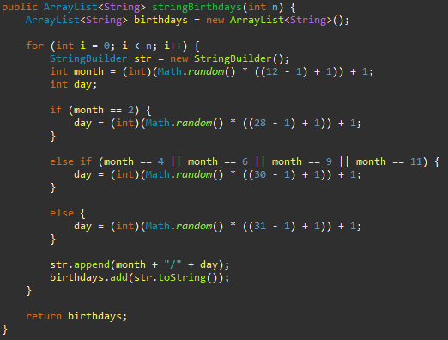

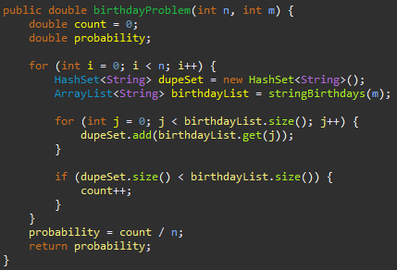

Birthday Problem Using (1 <= Day <= 365 Format)

* Given 100 runs & user input of 25 people

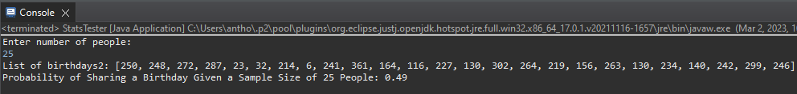Output:

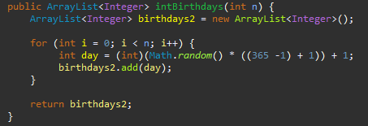

Birthday Problem Methods:

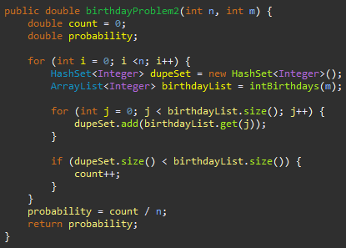

**Monty Hall Problem**

Monty Hall With No Change

* Given running program 10,000 times

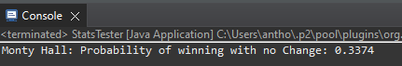

Output:

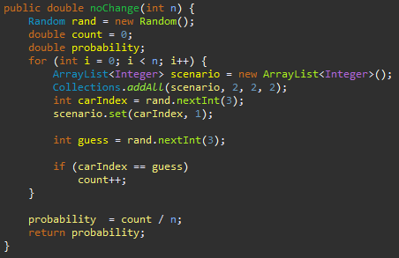

Monty Hall No Change Method:

Monty Hall with Change

* Given running program 10,000 times

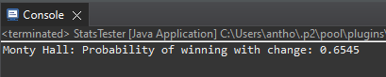

Output:

Monty Hall With Change Method: 